**Test Case 0001**

**System:** Bench

**Description:** Test that the dashboard is implemented correctly

**Severity:** 3

**Instructions**

**Test1**

1. Start the Bench application.
2. Click the button “Login” on the navigation bar.
3. Enter the email “team23project@gmail.com” into the text field labeled “Email address”.
4. Enter the password “12345678” into the field labeled “Password”.
5. Click the button “Login” below the field.
6. After the screen has loaded, three panels of different users’ profiles should appear, and the navigation bar should include buttons “Bench”, “Explore”, “My Profile”, “Settings” and “Logout”.
7. Click on the “View Profile” button of any of the three other user’s panels that the user would like to select.

**Expected Result:** A new page with the detailed profile information of the selected user should be displayed.

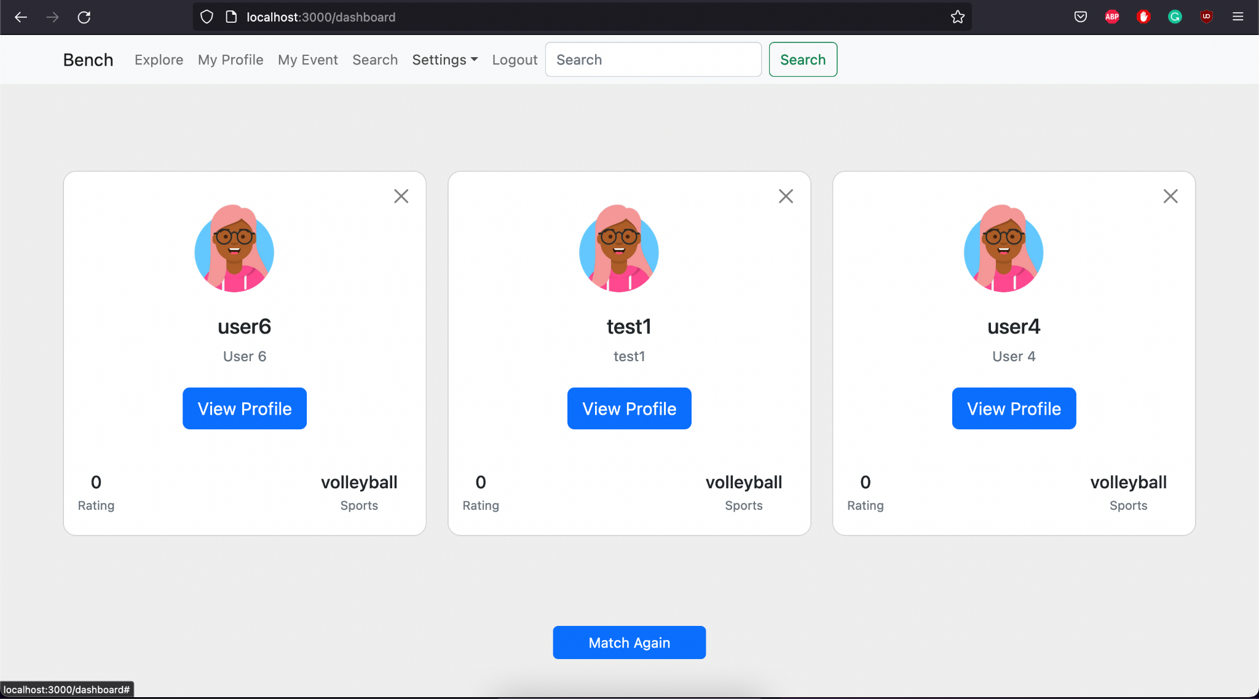

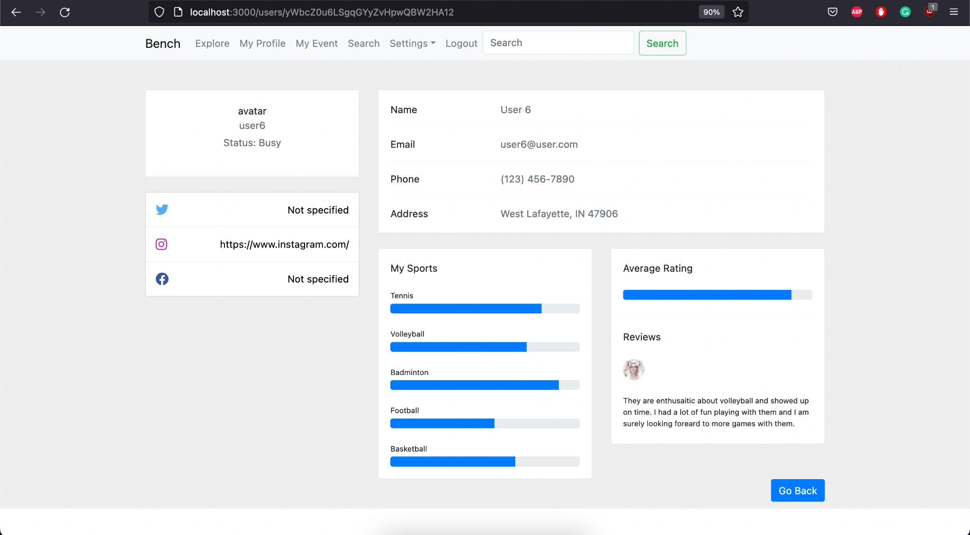

**Test2**

1. Start the Bench application.
2. Click the button “Login” on the navigation bar.
3. Enter the email “team23project@gmail.com” into the text field labeled “Email address”.
4. Enter the password “12345678” into the field labeled “Password”.
5. Click the button “Login” below the field.
6. After the screen has loaded, three panels of different users’ profiles should appear, and the navigation bar should include buttons “Bench”, “Explore”, “My Profile”, “Settings” and “Logout”.

**Expected Result:** On each user’s profile panel, there should be seen the related user’s brief profile information and a button labeled “View Profile”.



**Test 3**

1. Start the Bench application.
2. Click the button “Login” on the navigation bar.
3. Enter the email “team23project@gmail.com” into the text field labeled “Email address”.
4. Enter the password “12345678” into the field labeled “Password”.
5. Click the button “Login” below the field.
6. After the screen has loaded, three panels of different users’ profiles should appear, and the navigation bar should include buttons “Bench”, “Explore”, “My Profile”, “Settings” and “Logout”.
7. Click on the “View Profile” button of any of the three other user’s panels that the user would like to select.
8. After the user’s profile page is loaded on the screen, click button “go back”.

**Expected Result:** the user would be directed back to the “Explore” page where they could choose to reselect a different user.





